1. **ViewSet-based API**: ViewSets are classes that combine the logic for multiple HTTP methods (GET, POST, PUT, DELETE, etc.) into a single class. They provide a simple and powerful way to define API endpoints.

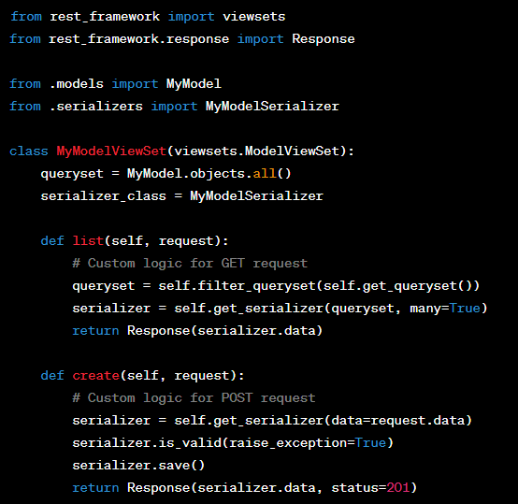

1. **Generic API**: Django REST framework includes a set of generic views that can be used to quickly build common API views. Examples include **ListAPIView**, **CreateAPIView**, **RetrieveAPIView**, **UpdateAPIView**, and **DestroyAPIView**.

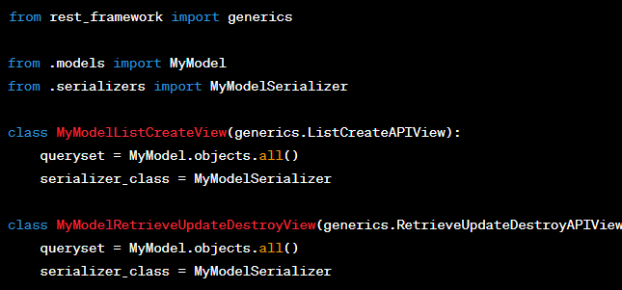

1. **ModelViewSet**: ModelViewSet is a convenient class that combines the functionality of a ViewSet with the common operations for a database model. It automatically provides CRUD operations (Create, Retrieve, Update, Delete) for a model.

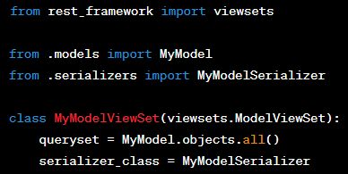

1. **Function-based API**: Django REST framework also allows you to define API views using plain functions. You can use decorators like **@api_view** to specify the supported HTTP methods and handle the request/response processing.

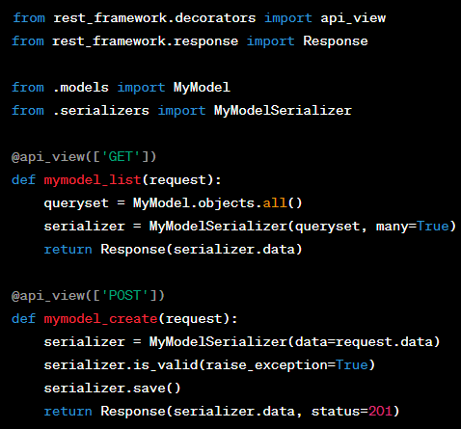

1. **APIView**: APIView is a base class for building API views. It provides more control and flexibility compared to ViewSets, as you define the request handling methods (e.g., **get()**, **post()**, etc.) explicitly.

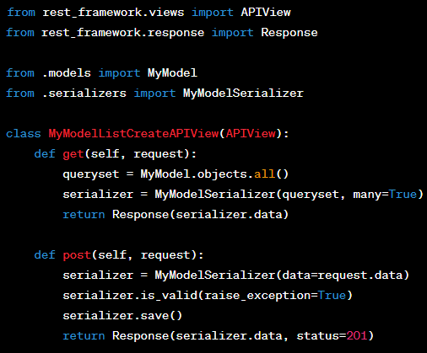

1. **Serializer-based API**: Serializers are used to convert complex data types (e.g., model instances) into JSON or other content types. Django REST framework provides serializers that allow you to define the input and output representation of the API data.

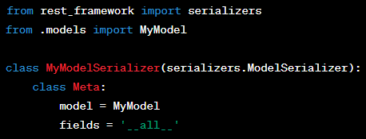

Serializer with all the functions:

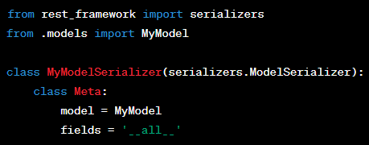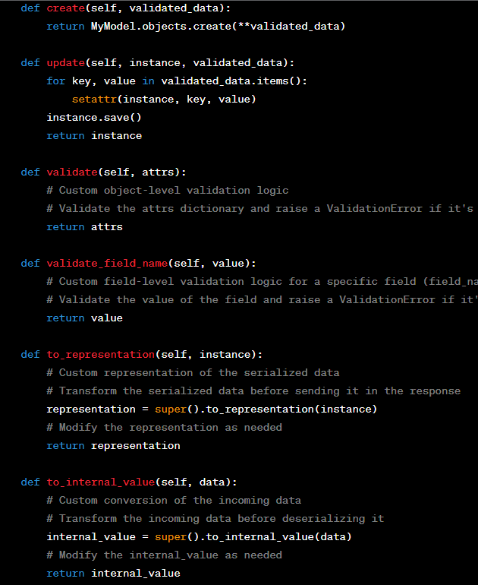

1. **Browsable API**: Django REST framework provides a browsable API feature that generates human-friendly HTML representations of the API endpoints. It allows developers to interact with the API through a web browser, making it easier to explore and test the API.

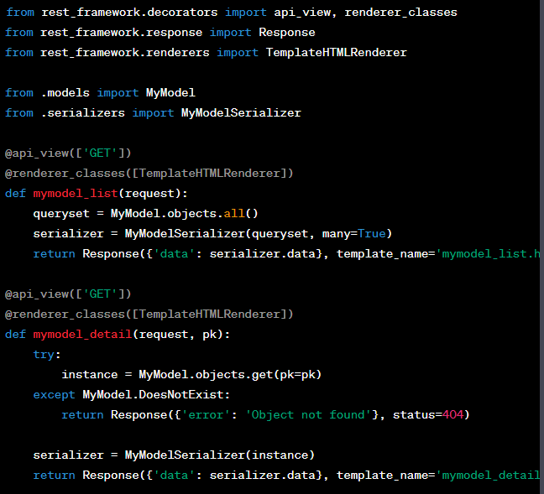

1. **Authentication and Permissions**: Django REST framework includes built-in support for authentication and permission handling. You can configure various authentication schemes (e.g., token-based authentication, JWT authentication) and apply permissions to control access to API endpoints.

Token based:

pip install djangorestframework djangorestframework-simplejwt django-cors-headers

